Pearspn’s r Correlation Template

PSYC300

AU23

* This is the template you will use to run a Pearson’s r correlation analysis.
* In this template, the predictor variable is labeled ‘predictor’ and the outcome variable is labeled ‘outcome’.
* You will be using the template to run a correlation analysis with your data.

## Step 1: Load required packages.

**You do not need to change anything in the chunk of code below. Simply run the code to load the libraries.**

library(DescTools)  
library(psych)

##   
## Attaching package: 'psych'

## The following objects are masked from 'package:DescTools':  
##   
## AUC, ICC, SD

library(ggplot2)

##   
## Attaching package: 'ggplot2'

## The following objects are masked from 'package:psych':  
##   
## %+%, alpha

library(dplyr)

##   
## Attaching package: 'dplyr'

## The following objects are masked from 'package:stats':  
##   
## filter, lag

## The following objects are masked from 'package:base':  
##   
## intersect, setdiff, setequal, union

## Step 2: Reading in your data.

**Remember to change this to the path/name for YOUR data!**

DF <- read.table("JennaCorrelationMethods.csv", header= TRUE, sep=",")

## Step 3: Exploring your data.

**View summary statistics of your dataset**

describeBy(DF)

## Warning in describeBy(DF): no grouping variable requested

## vars n mean sd median trimmed mad min max range  
## holdingdoor 1 10 3.6 0.52 4 3.62 0.00 3 4 1  
## complimenting 2 10 2.8 0.92 3 2.88 0.74 1 4 3  
## givingupseat 3 10 3.1 0.74 3 3.12 0.74 2 4 2  
## pickingupdroppeditems 4 10 2.9 0.88 3 3.00 0.00 1 4 3  
## numberofgoodqualities 5 10 1.7 0.48 2 1.75 0.00 1 2 1  
## dothingsaswellasothers 6 10 1.7 0.48 2 1.75 0.00 1 2 1  
## notproud 7 10 3.0 0.67 3 3.00 0.00 2 4 2  
## nogoodatall 8 10 2.5 0.97 3 2.50 0.74 1 4 3  
## positiveattitude 9 10 2.5 0.71 2 2.38 0.00 2 4 2  
## skew kurtosis se  
## holdingdoor -0.35 -2.05 0.16  
## complimenting -0.43 -0.83 0.29  
## givingupseat -0.12 -1.35 0.23  
## pickingupdroppeditems -0.73 -0.17 0.28  
## numberofgoodqualities -0.75 -1.57 0.15  
## dothingsaswellasothers -0.75 -1.57 0.15  
## notproud 0.00 -0.97 0.21  
## nogoodatall -0.33 -1.25 0.31  
## positiveattitude 0.85 -0.75 0.22

## Step 4: Naming your variables.

**Remember to change your predictor name and outcome name to the EXACT name of your data/variable in your data! You can review variable names from the describe.by function output.**

ActsofKindness<- DF[,1:4]  
SelfEsteem<- DF[,5:9]

SelfEsteem$notproud<- 5 - SelfEsteem$notproud  
SelfEsteem$nogoodatall<- 5 -SelfEsteem$nogoodatall

SelfEsteem$total <- SelfEsteem$numberofgoodqualities + SelfEsteem$dothingsaswellasothers + SelfEsteem$positiveattitude  
ActsofKindness$total <- ActsofKindness$holdingdoor + ActsofKindness$complimenting + ActsofKindness$givingupseat + ActsofKindness$pickingupdroppeditems

## Step 5: Examine statistical assumptions (diagnostics).

We will make a quick scatter plot to assess homoscedasticity and linearity. Look for funnel shapes and curves.

ggplot(DF, aes(x=ActsofKindness$total, y=SelfEsteem$total)) +   
 geom_point() +   
 geom_jitter() +   
 ggtitle("Scatterplot") +   
 labs(y="SelfEsteem", x = "ActsofKindness")

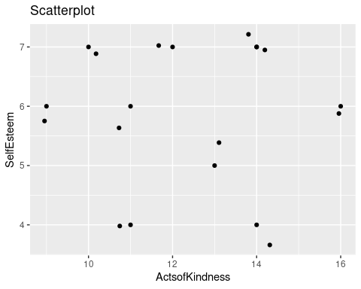

## Step 6: Run the analysis and make an inference.

**If you did the above step correctly, you do not need to change anything in the chunk of code below. Simply run the code to run the analysis.** The code follows the format: cor.test(DF $predictor,DF$ outcome)

cor.test(ActsofKindness$total,SelfEsteem$total)

##   
## Pearson's product-moment correlation  
##   
## data: ActsofKindness$total and SelfEsteem$total  
## t = -0.072587, df = 8, p-value = 0.9439  
## alternative hypothesis: true correlation is not equal to 0  
## 95 percent confidence interval:  
## -0.6448648 0.6138874  
## sample estimates:  
## cor   
## -0.02565509

## Step 7: Visualize the results.

**Remember to change the following information IN THE CODE CHUNK BELOW.** These are the descriptions for what you will need to fill in where there is green text (character strings) in the code block below.

1. Your graph title (ggtitle) = This can be anything you want within reason. Make sure it stays within the (““).
2. Your y-axis title (y= in labs) = This can be anything you want. For example, if your variable name is TimeSleep you can name the axis “Time Spent Sleeping”. Make sure it stays within the (““).
3. Your x-axis title (x= in labs) = This can be anything you want. For example, if your variable name is ExamScore you can name the axis “Score on Exam”. Make sure it stays within the (““).
4. X and Y scales. For both the x- and y-axes, adjust the scale. The first number is the start and the second is the end. The third is the interval (tick marks—make these reasonable). Note that you should base these on your data. If the range is too extreme, no tick marks will appear on the axis.

ggplot(DF, aes(x=ActsofKindness$total, y=SelfEsteem$total)) +   
 geom_point() +  
 geom_jitter() +  
 scale_y_continuous(breaks=seq(5,9,by=1)) +   
 scale_x_continuous(breaks=seq(1,4,by=1)) +   
 ggtitle("Graph") +   
 labs(y="SelfEsteem", x = "ActsofKindness")

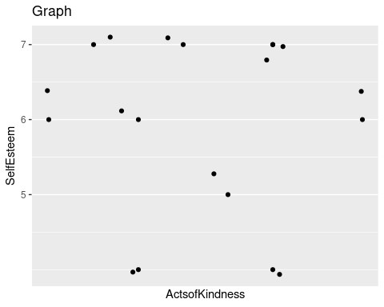

## Step 8: Knit the file to Word.

You will see a blue yarn ball icon with the word ‘Knit’ next to it at the top of the screen. Click the small arrow to the right of ‘Knit’ and then click ‘Knit to Word’.

### End of script